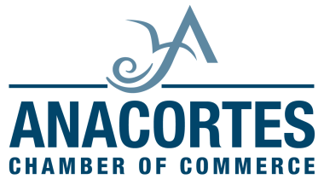
These are the step by step instructions to choose your job shadow
To access website
http://www.experienceworkproject.com/students/opportunities/
- Select Anacortes High School
- Enter password: AHS1000
- See Database Download – CLICK Job Shadows Database
- See chart of actual employer opportunities
- Choose the ID# (Write it down) of the place you want to do your job shadow
- Return to Student/Opportunities/Page
- See Application Instructions
- CLICK on Download Application
- SAVE application to thumb drive, hard drive, or whatever you may have
- Type all sections of application and SAVE again (place first and last name in title when you save it)
- Return to Student page (Automatic when you save file)
- Type in “Your Name” fill in box and “Your E-mail” fill in box
- Browse for your saved file and attach your completed APPLICATION
- Type in Anti-Spam Code exactly as you see it in the Box
- CLICK Submit Application
If you have further questions please contact:
Genny Korvin
EWP Coordinator
ewp@experienceworkproject.com
360-428-8547 – office at the Mount Vernon Chamber

